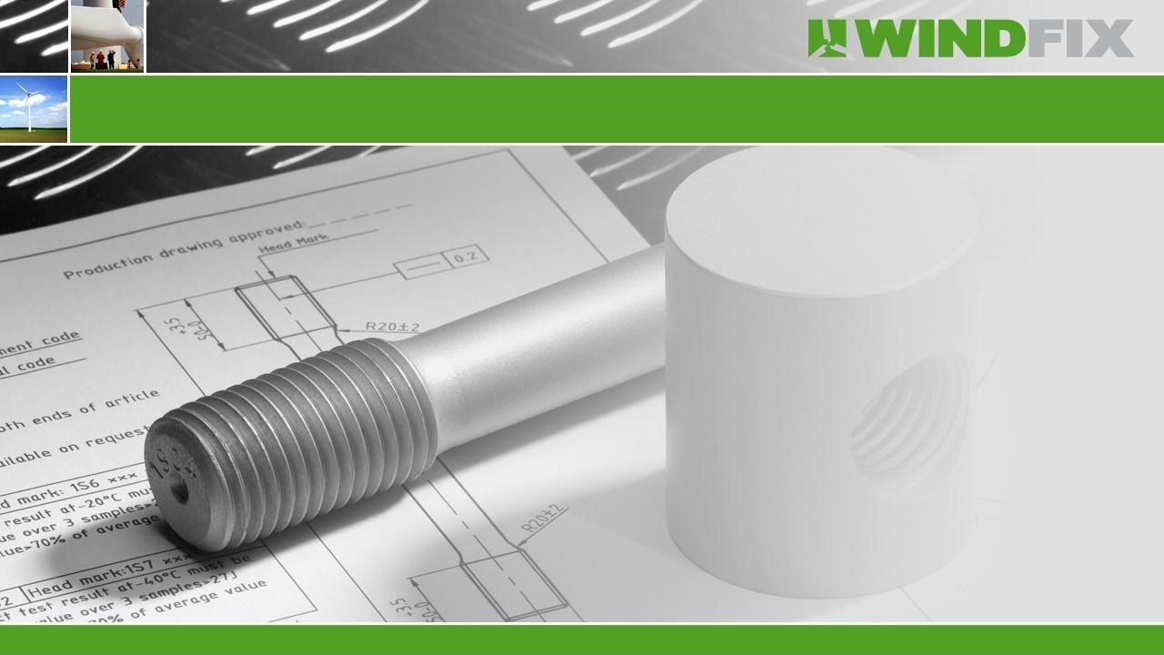

**Wind**

**-**

**Fix**

**P**

**resentation**

Member of

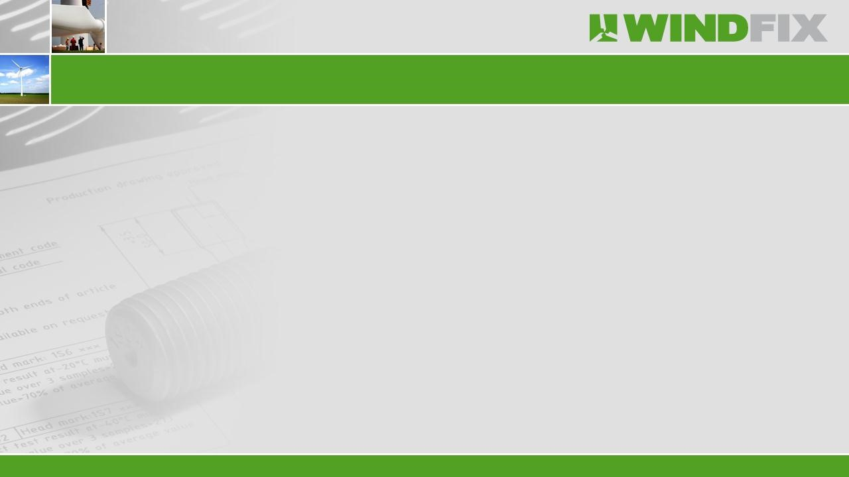

Founded in 1988 as a trading company in stainless steel fasteners.



Multi

-

Fix Group consists of 2 companies with approximately 90 employees.



Turnover

€

,

17.000.000

-

Euro in 2014.

Fasteners: Mechanical fasteners and related products.

Specials: Customized metal components and assemblies.

Solar

:

Components and mounting systems for solar

energy.

Wind

-

Fix: Components for wind turbines.

**Key**

**figures**

**Multi**

**-**

**Fix Group**



Business

Scope

:

Connectors for

wind

and hydraulic turbines and

related

metal and

plastic

components.



Producer

and

supplier

of European

quality

blade

connectors

and

high

s

trength

fasteners

.



Head

office in The

Netherlands (

Bergeijk

and subsidiary

)

in

China (Shanghai).



ISO

9001

accredited

and

GL

Prüfung

.



Customers such as LM,

Suzlon

, GE, JSW and

Vestas

.

**Key**

**figures**

**Wind**

**-**

**Fix**



Wind

-

Fix has a complete range of products like:

•

Inserts

•

Barrel /

Cylindrical

nuts

•

Studs

•

Foundation studs

•

Thread rods

•

High

strength

bolts

,

high

strength

nuts

and

h

igh

strength

washers

•

Din

6914

/

Din

6915

/

Din

6916

**Products**



Several finishing's / surface treatment:

•

Delta MKS coating

•

Dacromet

/

Geomet

•

Hot dip galvanizing

•

Phosphating

or

phosphatizing

•

Zink plating

•

Sherardising

or

vapour

galvanising

**Products**



**Products**

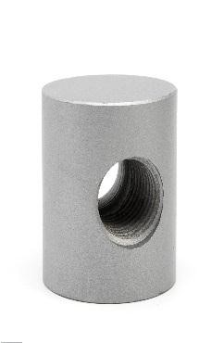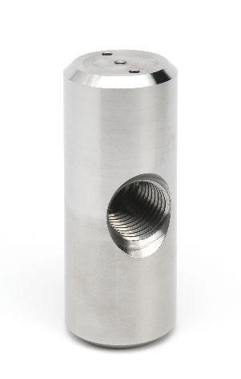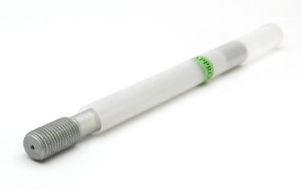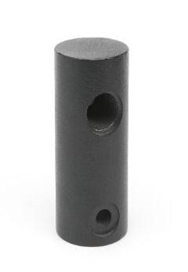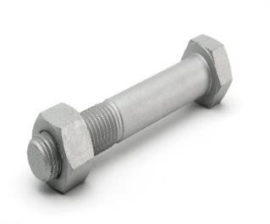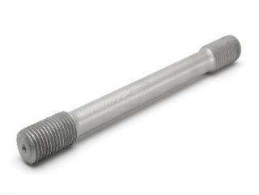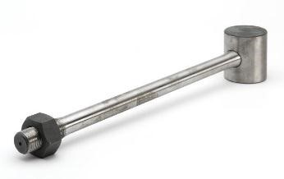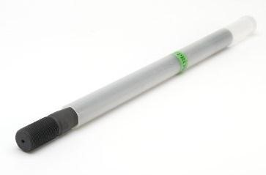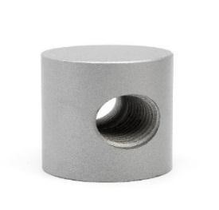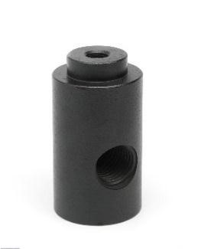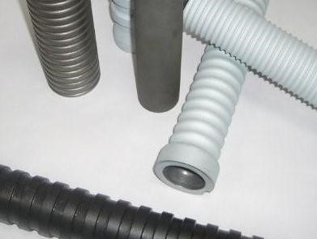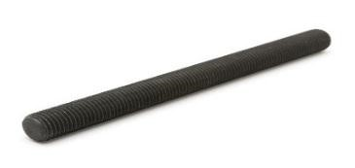

Production

facility in

Shanghai:

•

CNC

c

entres

•

CNC machines

•

NC machines

•

Sawing machines

•

Drilling machines

•

Thread tapping and thread rolling

•

Capacity up to 200 Tons of raw material per month

**Production**



**Production**

**and**

**W**

**arehousing**

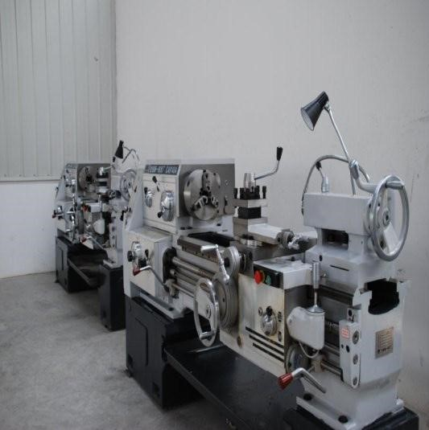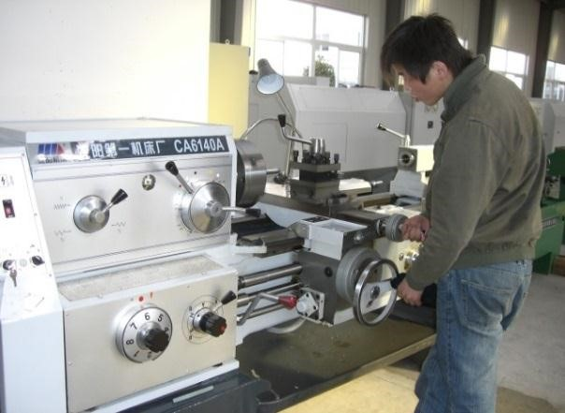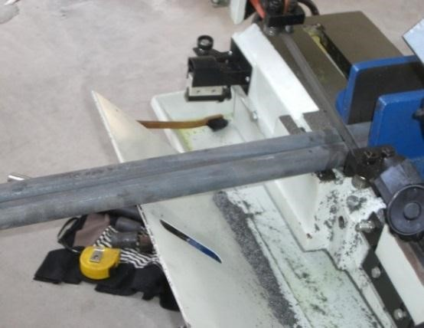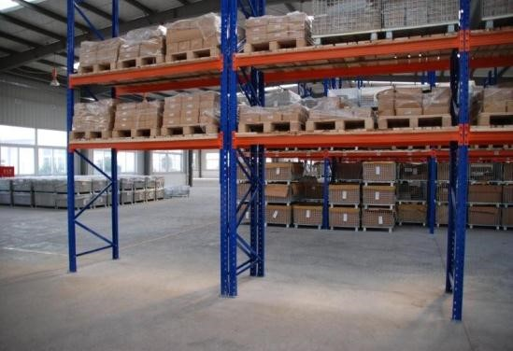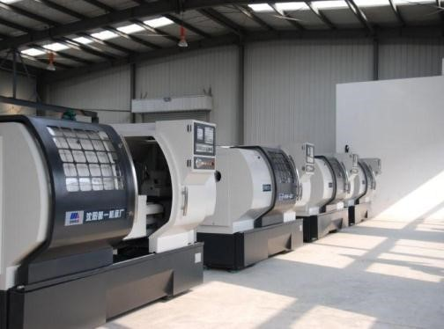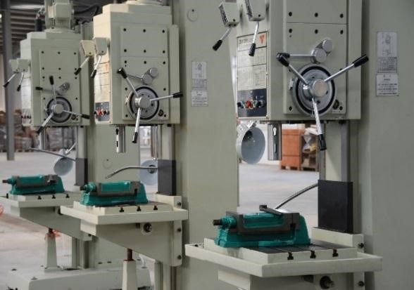

Germanischer

Lloyd’s accredited Laboratory:

•

Mechanical analysis

•

Tensile strength (up to 200 tons pulling machine)

•

Yield strength

•

Elongation

•

Hardness

•

Impact value test (up to

-

60

°

C)

•

Chemical material analyses

•

Ultrasone

testing and MT

-

testing

•

Salt spray

testing

•

Microscope inspections

**Quality**

**Control**



**Quality**

**Control**

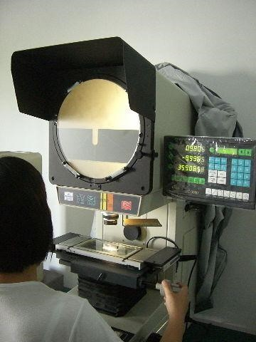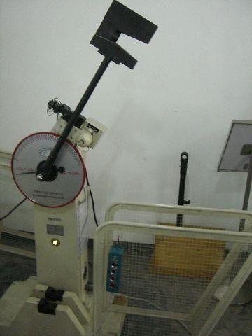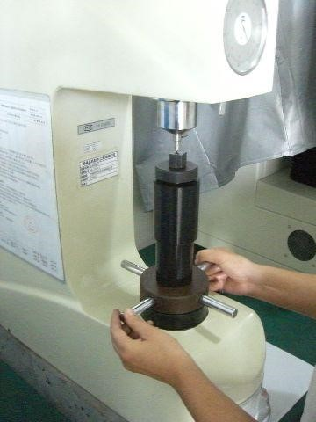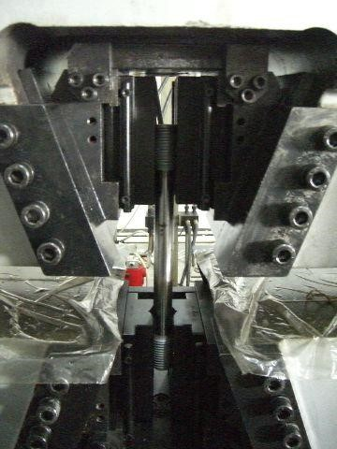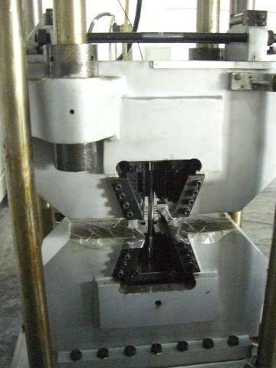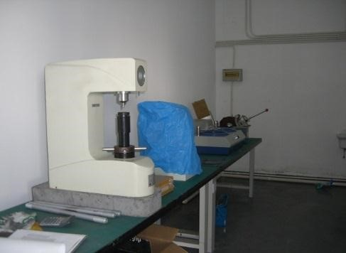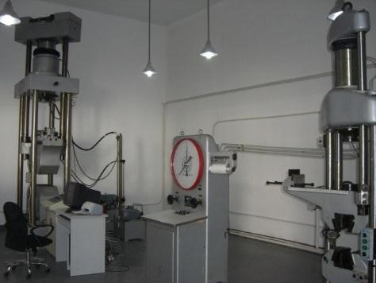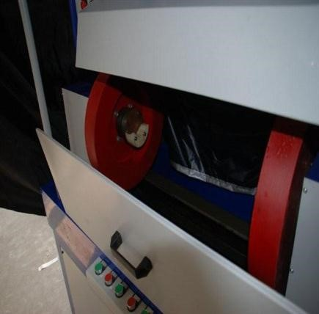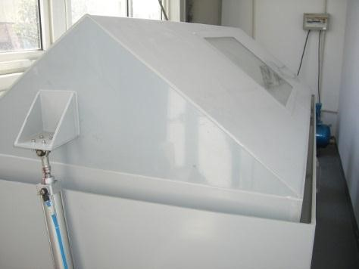

**Quality Management**

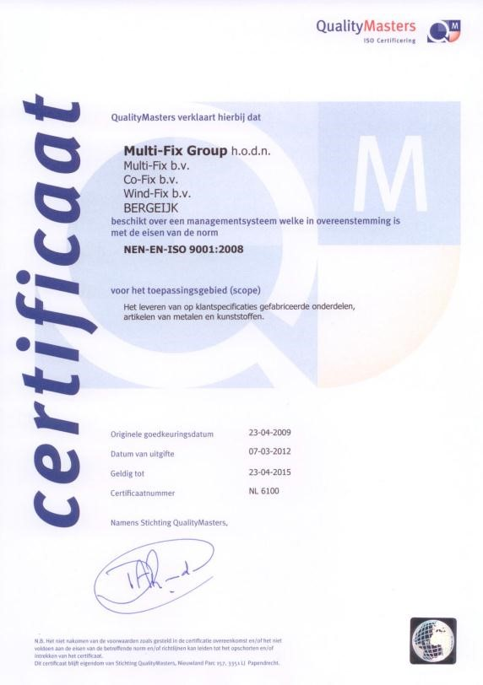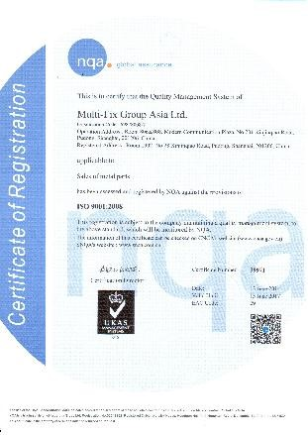

**Wind**

**-**

**Fix Europe**

**BV**

**Member of Multi**

**-**

**Fix Group BV**

**P.O. Box 93**

**5570**

**AB**

**Bergeijk**

**Bokkerijder**

**24**

**-**

**26**

**5571**

**MX Bergeijk**

**Netherlands**

**T. +31 497 55 29 29**

**F. +31 497 55 29 55**

[**www.multifixgroup.co**](http://www.multifixgroup.com/)

[**m**](http://www.multifixgroup.com/)